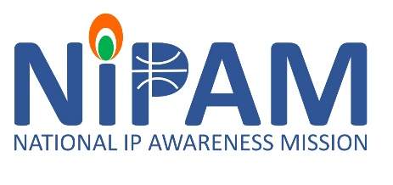
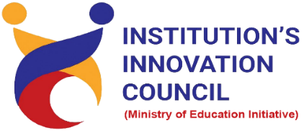

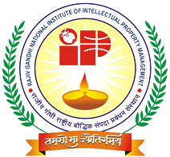
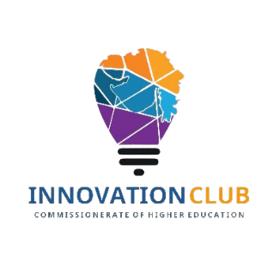
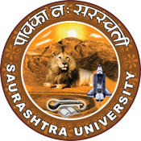

Intellectual Property Rights (IPRs) and IP management for startup
18 May 2022
At
Virtually on Webex
Saurashtra University Campus, Rajkot
Contents
Saurashtra University – IIC 2
Event Schedule 2
Event Registration Link 2
Brief about Event 3
Key Points 3
Outcome 3
About the Speaker/Chief Guest 4
Connect Us: 5

Saurashtra University – IIC
The university is dedicated to instruction, research, and extending knowledge to the public (public service). Ministry of Education (MoE), Govt. of India has established ‘MoE’s Innovation Cell (MIC)’ to systematically foster the culture of Innovation among all Higher Education Institutions (HEIs). The primary mandate of MIC is to encourage, inspire and nurture young students by supporting them to work with new ideas and transform them into prototypes while they are informative years. Saurashtra University is one the Organization that have constituted the IIC to foster the vision of MoE and be a part for the promotion and development of innovation ecosystem.

Event Schedule

Event Registration Link

bit.ly/IPMS-SUSEC

Brief about Event
Saurashtra University Start-up & Entrepreneurship Council (SUSEC) collaboratively with Office of the Dy. Controller of Patents & Designs, IPO Mumbai/RGNIIPM Nagpur Under the National Intellectual Property Awareness Mission (NIPAM), organizing a virtual session on " Intellectual Property Rights (IPRs) and IP Management for Start-ups " via Video Conferencing Mode.
National Intellectual Property Awareness Mission (NIPAM) under the initiative of the Government's "Azadi ka Amrit Mahotsav". The pan-India ambitious mission aims to provide awareness on Intellectual Property and its rights to 1 million students. It aims to inculcate the spirit of creativity and innovation to students of higher education (classes 8 to 12) and ignite and inspire the students of college / Universities to innovate and protect their creations.
Awareness regarding various types of IP including Patent, Trademark, Design, Copyright, Integrated Circuit Design and Plant Varieties registration was carried out.
Details, eligibility, how to apply, who can apply and importance of the IP was introduced.

Key Points

During the session, below mentioned points were discussed:
- Importance of IP.
- IP & Youth innovating for a better future.
- How IPO office supporting the start-ups.
- Progress of IP office.
- Background of Intellectual property.
- Significance of Intellectual property.
- Rights of Patentee
- How to apply for Patent, Trademark, Design Registration and Copyright registration.
- FAQs related to Patent, Patent filing on Ip was discussed.

Outcome

As per the event, various types of IP and who can apply were understood by the speaker with various examples. Also, as it was related to Intellectual property and awareness creation, a basic knowledge of intellectual property, how it works, how it can be registered, with various examples of Trade dress, Copyright, patents etc. It was very good informative session. Students learn a lot about various type of Intellectual property for patent, design, copyrights. How to file it and various process etc.

About the Speaker/Chief Guest

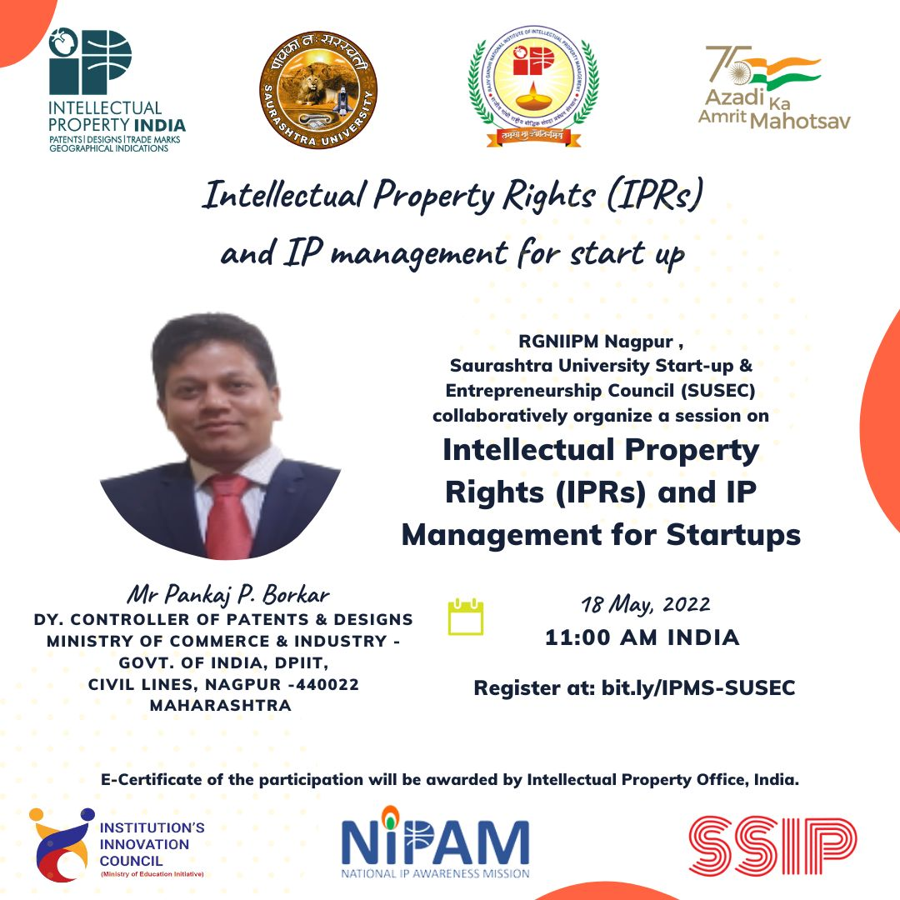
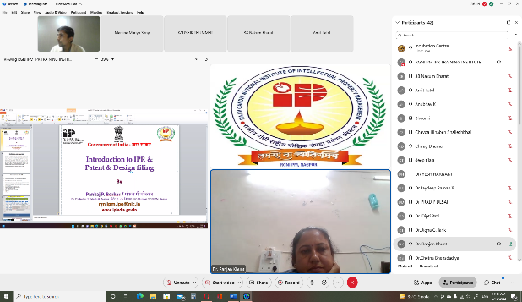
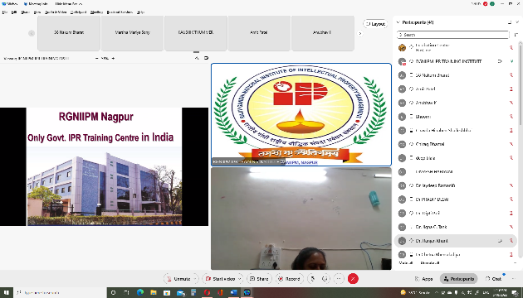

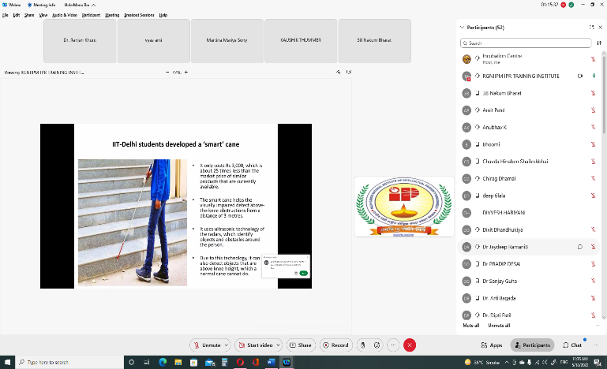
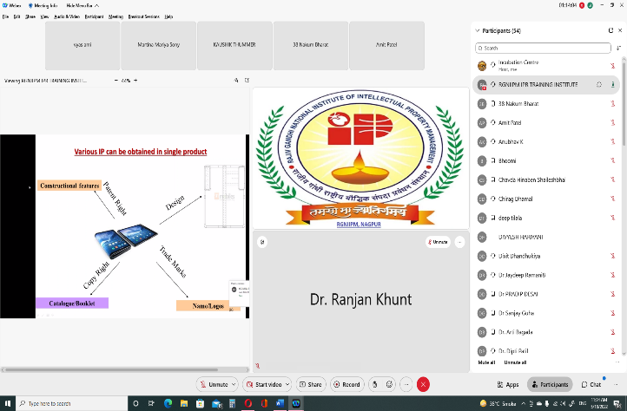
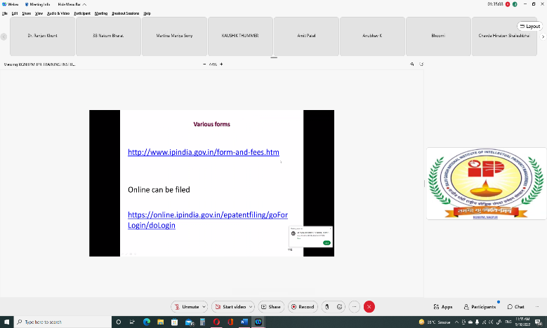
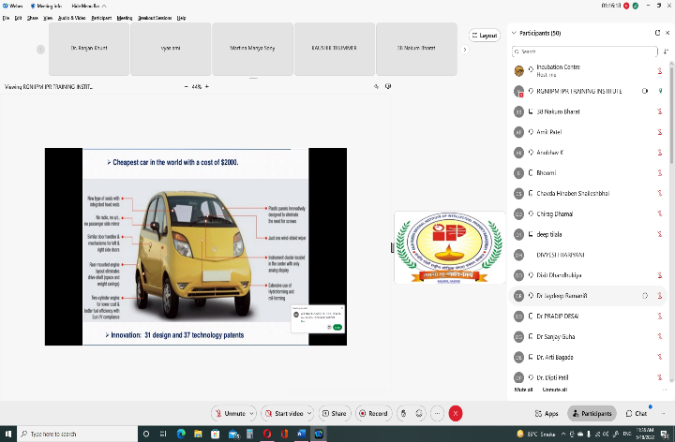

Connect Us:
https://www.linkedin.com/company/susec iic@sauuni.ac.in
https://www.facebook.com/iicsauuni bit.ly/SU-SSIP Location
https://www.instagram.com/susecrajkot https://bit.ly/SUSEC-youtube

